Field Science Course and Genome Science Course in 2015 (fall)

1.1 Outline
“Field Science Course” aims to train students to do fieldwork on the UNESCO World Natural Heritage Site on Yakushima Island, Japan. Young scientists from abroad and graduate students in Kyoto University attend the course together, using English as an official language.
“Genome Science Course” aims to train students in the molecular biology. In this course, various samples collected in the preceding “Field Science Course” will be analyzed. Through the two courses, students will experience the whole process of scientific research, sampling in the field, analyzing in the laboratory, conducting data analysis and presentation of the results.
No previous experience is required to take these courses and we welcome both students who engage in fieldwork and those who engage in laboratory work. We also welcome students who have few chances to communicate in English. Please communicate with foreign students of the same generation.
In the Field Science Course, students will learn the fundamental methods to study the ecology and behavior of various wild animals. We stay in a small village, having local food. We hope you enjoy the nature and culture of Yakushima Island.

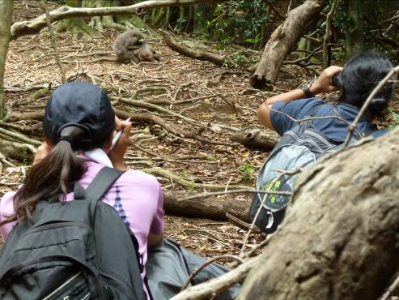 | 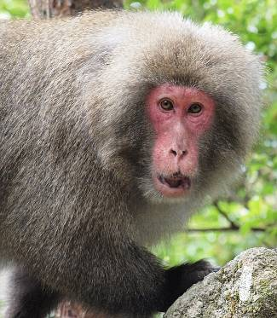 | 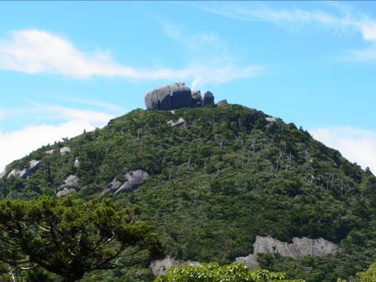
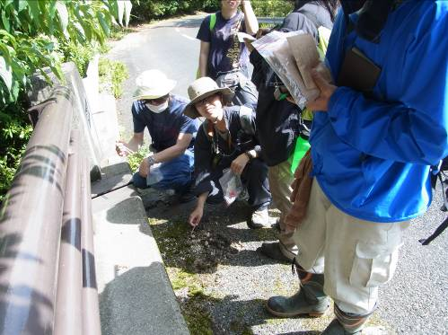 | 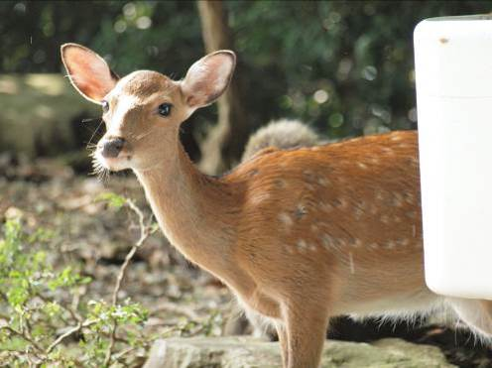 |  | 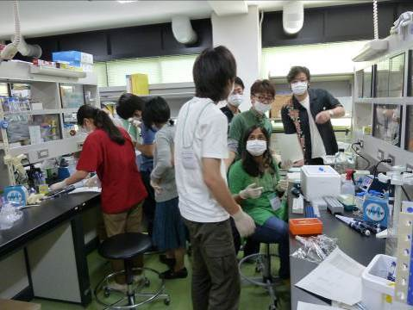

1.2 Application
A graduate student of Biological Science, Faculty of Science, Graduate School of Kyoto University (as of October 2015) can apply for the courses. Please note that we accept a limited number of participants due to safety for fieldwork and limited capacity of accommodation and transportation.
We will hold the course twice this year, in spring and fall. The contents of spring and fall courses are different, and students may take only one of them. If an applicant was unaccepted for the spring course, he/she may apply again for the fall course.
In both seasons, the Field Science Course will be held in Yakushima Island. We hold the Genome Science Course at Yoshida Campus of Kyoto University in Kyoto City in spring, and either at the Primate Research Institute in Inuyama City (deer course) or at Yoshida Campus (plant course) in fall.
Students may apply to either the Field Science Course or Genome Science Course, though we encourage taking both of the courses.

1.3 Fee
Typically, no fee is required. During the Field Science Course in Yakushima, please pay by yourself the cost of optional activities such as entrance fee of sightseeing sites, public bath and snacks and meals other than those provided in our field station.
A participant must pay about 12,000 yen for meals and daily necessities during Yakushima Filed Science Course before the course, though this cost is paid back to you later.

2. Schedule
September 13 Deadline for application (both for the Field Science Course and Genome Science Course)
Early October Guidance for the Field Science Course and Genome Science Course, at PRI, Inuyama.

Field Science Course (Yakushima Island, Kagoshima Prefecture)
October 18 Field Science Course starts (Move to Yakushima on this date)
October 19—22 Fieldwork in Yakushima
October 23 Data analysis, presentation in the afternoon
October 24 Leave Yakushima

Genome Science Course at Kyoto University (either Inuyama or Kyoto)
October 26—30 Genome experiments, at several laboratories in Inuyama (animal) and
Yoshida (plant) Campus of Kyoto Univ.
November 5 Presentation of the result of the courses at Primate Research Institute

Reports on the past program
Global COE website (in English)
http://gcoe.biol.sci.kyoto-u.ac.jp/gcoe/eng/report/2011/01/report_of_fieldworkgenome_trai.php

フィールド＆ゲノム科学実習 CCTBio HP (in Japanese)
http://www.wrc.kyoto-u.ac.jp/core-to-core/training_old.html

3. Field Science Course in fall (October 18-24)

3.1 Participants
About 20 graduate students of Biological Science, Kyoto University
About 6 teaching staff, including professors, post-docs and graduate students who study in Yakushima and/or the subject species

3.2 Groups
We form into two groups, deer and plant groups, and each group engages in different tasks. Choose your first and second preferences for group assignment. Please note that we cannot ensure your first preference due to capacity limitations.

A) Deer group
Title
Deer feces as a source of added information to enhance population census data
シカの糞から個体群調査のための情報を得る

Lectures
Takakazu YUMOTO (Primate Research Institute, Kyoto Univ.) 湯本貴和(京都大･霊長研)
Goro HANYA (Primate Research Institute, Kyoto Univ.) 半谷吾郎(京都大･霊長研)
Akiko SAWADA (Wildlife Research Center, Kyoto Univ.) 澤田晶子(京都大・野生動物）

Abstract
Fecal pellet counting is a conventional census technique used in wild ungulate populations to estimate their abundance. The value of the data would be much improved if we could obtain more information from the feces that were counted in the census. Participants will collect fresh feces while following habituated deer individuals in the forest, and examine the whether variation in fecal pellet size is correlated with the animal’s biological characteristics observable in the field, such as body size, age, sex, and reproductive status. The fecal samples will be used for molecular analyses of DNA and hormones to determine sex, individual, and reproductive status of the deer in the following Genome Science Course. The correlations between observable characteristics in the field and molecular profiles determined in the laboratory may contribute to interpreting results achieved during the population census.

B) Plant group

Title
Species composition and phenology in fern gametophytes
シダ植物の配偶体における種構成とフェノロジー

Lectures
Wataru SHINOHARA (Kagawa Univ.) 篠原渉(香川大学)
Hiroshi KUDOH (Center for Ecological Research, Kyoto Univ.) 工藤洋(京都大･生態研)

Abstract
Ferns that we typically observe in forests are in their sporophyte (胞子体) stages. Compared with sporophytes, fern gametophytes (配偶体) are very small, about 1 cm at most in size, and to date no sufficient morphological characteristics useful for species identification have been identified, as is the case for other tiny characterless kinds of organisms. Recently, however, developments in molecular analysis are shedding light on species identification for these small organisms. This year, the plant team focuses on studying phenology of fern gametophytes in Yakushima. We plan to collect gametophytes from several places and compare their species compositions to that of samples collected in the other seasons during the previous year.

4. Genome Science Course in fall (October 26-30)

Following the Field Science Course, we will have the Genome Science Course, which uses samples collected during the Field Science Course on Yakushima Island. We also recommend taking the following course that corresponds to that which you took during the Field Science course. These combinations enable you to analyze the samples you yourself have collected. Prior knowledge in molecular biology is not necessary for the Genome Science Course in fall. This course is open either at the Primate Research Institute, Kyoto University in Inuyama City (deer group) or at the Graduate School of Science, Kyoto University in Yoshida Campus (plant group).

Genome Science Course | Field Science Course
A) Deer group | A) Deer group (at Primate Research Institute)
B) Plant group | B) Plant group (at Yoshida Campus, Kyoto Univ.)

A) Deer group

Title
DNA and hormonal analyses of deer feces for the determination of sex and reproductive status

Lectures
Hiroo IMAI (Primate Research Institute, Kyoto Univ.) 今井啓雄(京都大･霊長研)
Kodzue KINOSHITA (Primate Research Institute, Kyoto Univ.) 木下こづえ(京都大･霊長研)
Takushi KISHIDA (Wildlife Research Center, Kyoto Univ.) 岸田拓士(京都大･野生動物研究センター)
Takashi HAYAKAWA (Primate Research Institute, Kyoto Univ.) 早川卓志(京都大･霊長研)

Abstract
By applying two molecular methods (DNA and hormonal analyses), participants will determine the sex and reproductive status of Yakushima deer from feces collected during the Field Science Course. First, deer genomic DNA will be extracted from the feces. The participants will determine the deer sex by amplification of genes located on the sex chromosomes. Second, participants will also analyze the sex steroid hormones (estrogen, progesterone, and testosterone) from the same deer feces to determine sex. In addition, by measuring the concentration of each hormone, the participants will estimate the reproductive status of deer. Because fall is the breeding season for deer, if female and male adults are in estrus and in rut, respectively, female (estrogen/progesterone) and male (testosterone) hormones will show high concentrations. Based on the results from these two molecular analyses, we will try to develop practical methods for estimating reproductive status of wild deer.

B) Plant group

Title
Species composition and phenology in fern gametophytes

Lectures
Shizuka FUSE (Faculty of Science, Kyoto Univ.) 布施静香(京都大･理学研究科)
Wataru SHINOHARA (Kagawa Univ.) 篠原渉(香川大学)
Hiroshi KUDOH (Center for Ecological Research, Kyoto Univ.) 工藤洋(京都大･生態研)

Abstract
For the gametophyte samples collected from Yakushima, we will try to identify the species or the genera to which they belong using molecular analysis. We will extract DNA from the samples and determine rbcL gene sequences from them. Subsequently, we will compare these sequences with registered DNA sequences in the gene bank.

5. Information on fieldwork and life in Yakushima Island

5.1. Fieldwork

Research in lowland forest
The main study site is located in the western lowland forest in Yakushima. In the forest, the canopy is closed and the forest floor is dark. Undergrowth is sparse and not bushy. There are no trails in the forest, but we can walk through most parts of the forest easily. We sometimes walk on steep slope and cross streams. Please wear long trousers and shoes to protect your legs and feet in case you lose your balance.
During the month of May, you may get bug bites (mostly mosquitoes). A long-sleeved shirt is good for protection from insect bites. Wear a long-sleeved shirt, if you have sensitive skin. We also walk on the road to search for animals and their feces. Sunlight is strong on the road so you will need a hat.
In the forest, visibility is poor and you need to confirm your location using a map and compass.

Weather
Air temperature is about 18-26 °C in May and 19-25 °C in October in lowland. Note that air temperature is much lower in high-altitude mountainous areas.
Yakushima Island is famous for rainy climate. Early June is the beginning of rainy season and it is likely to rain in late May.

What to wear on the field
･Long-sleeved shirt, long trousers, hat or cap
In general, it is better to wear a long-sleeved shirt and long trousers to cover your skin on the field. They will protect you from insect bites, scratches and strong sunlight. Sunlight is very strong in May. Long trousers should be soft and loose enough to walk on steep slopes. Avoid tight jeans, because they become heavy and hard when they are wet.

･Shoes
Avoid slippery shoes or those that do not cover your foot, such as sandals.
Mountaineering shoes are the best, if you have. We recommend them, if you do not have enough experience in walking in hilly forests.
Jogging shoes or sneakers are good in lowland forest, though they are not water proof. They should be tough enough to walk on the rocky slope.
If you have old mountaineering shoes, jogging shoes or sneakers (more than 3 years), check their soles. Old bond may become weak and the soles can fall apart. Almost every year, one or two participants have had their soles fall apart.
Long boots are also good, if you are experienced in walking in the mountain with long boots.
･Gloves
You may wear gloves if you like. Thin gloves are good for manipulation, such as taking notes.

5.2. Accommodation and meals
In Yakushima, we stay in the field station (PWS House Yakushima) of Kyoto University in Nagata Village. All meals are provided during our stay in the field station. For dinner, you can enjoy local foods cooked by local people. Students and staffs will not cook except for the BBQ on the last night. We wash dishes and clothes and clean the rooms by ourselves.

Do it yourself in the field station
We have no housekeeper in the station. You will be responsible for maintaining the station and doing daily chores such as cleaning, washing clothes, packing lunch, washing dishes, taking out the garbage, etc. Please do these things actively and cooperatively.

Meals
Meals are cooked by residents in Yakushima. Please help them cook when necessary. If you have food allergy or food(s) to avoid (e.g., meat for vegetarian), please let us know.
We pack lunch by ourselves. Bring a lunchbox of your preference and utensils necessary (spoon, fork, chopsticks, etc.).

Room and bedding
In the Field Station, there is a dining hall, kitchen, 3 shower rooms and 3 restrooms. You will share one of 5 bedrooms with other students (4 people/room). Each bedroom has two bunk beds with mattresses. Please bring your own sleeping bag and/or warm clothes, as the temperature may drop to 15 degrees at night. Expensive, high-quality sleeping bag is not necessary as we stay inside the house at night.

Bath
There are three shower rooms. We prepare shampoo and soap, which you can use freely for bathing. If you prefer your own shampoo or soap, please bring them. Have your own towel for bathing.
As it takes a long time for everyone to take a shower, some of us may go to public bath. You can try Japanese public bath, if you like. When you go to a public bath, have soap and a towel with you.

Washing clothes
Two washing machines are available. We will provide the laundry detergent. Please wash your clothes together with those of other station members, to save time. We prepare mesh bags for washing, for which you can put your clothes in. Do not start washing after 10 p.m., to avoid making noise and inconveniencing others.

Others
You may bring sandals, which may be useful for walking around the station.

Shopping
In Nagata Village, you can buy snacks, drinks and daily necessities at a small shop. There are no supermarkets or convenience stores in the village. There is a supermarket in Miyanoura (20 km from the field station), the largest town in Yakushima Island, but you will not have time to go shopping there. You will have some time for shopping, on the last day.

5.3. List of personal equipment
Equipment for field research (common to all groups)
In addition to below, some other equipments will be necessary depending on your activity. Special equipment in each group will be announced later.

□ backpack (20-30 litters is enough)
□ notebook (pocket size is good)
□ pen / pencil
□ marker (with which you can write on plastic sample bags and plastic tubes)
□ canteen (you may use a PET bottle)
□ lunch box and spoon, fork, chopstick (bring a plastic container to pack your lunch to Yakushima)
□ flashlight (and batteries)
□ whistle (we can lend some whistles. Please let us know if you do not have it)
□ sampling bag, tube, etc. (they are given to participants at Yakushima)
□ maps (they are given to participants at Yakushima or Kyoto)
□ poison remover (they are given to participants at Yakushima)
□ backpack cover, or plastic bag inside the backpack (optional, when it is rainy)

□ long trousers (and a belt, must)
□ socks (must)
□ rainwear / umbrella (when it is rainy)

□ insect repellent (optional)
□ antipruritic (optional)
□ sunscreen (optional)
□ snack, candy, etc. (optional)
□ adhesive tape (optional, each lecturer has a first-aid kit)
□ towel (optional)
□ tissue (optional)

□ vest (optional)
□ waist pouch (optional)
□ spats optional)
□ gloves (optional)

□ camera (optional)

Other equipments for stay at the field station
□ sleeping bag (must)
We stay at night in the house and inexpensive one is good enough.
□ underwear
□ clothes (which you can wear in the house)
□ sandals
□ towel
□ soap (for public bath)
□ toilet kit
□ laptop (optional; a personal laptop computer is useful for data analysis and presentation of the results)

