“Advanced training in field biology” in 2022 Winter

1.1 Outline
The main purpose of “Advanced training in field biology” is to experience field research. In this course, the participants will tackle with research planning and data collection. The content of the training often involves exploratory research, and the results may be different from those expected. Participants are required not only to complete the prepared menus, but also to understand the research contents well, participate in the discussions, and come up with ideas. No previous experience is required to take these courses and we welcome both students who engage in fieldwork and those who engage in laboratory work.
During the field biology course, we stay in a small village and eat local food. We hope you enjoy the nature and culture of Yakushima Island.

We usually carry out two courses, “advanced training in field biology” and “Advanced laboratory skills” successively, taking samples in the former course and analyze them in the latter course. However, in this time, “advanced laboratory skills” is not held, due to the schedule.

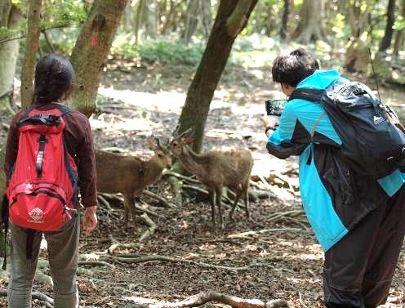 | 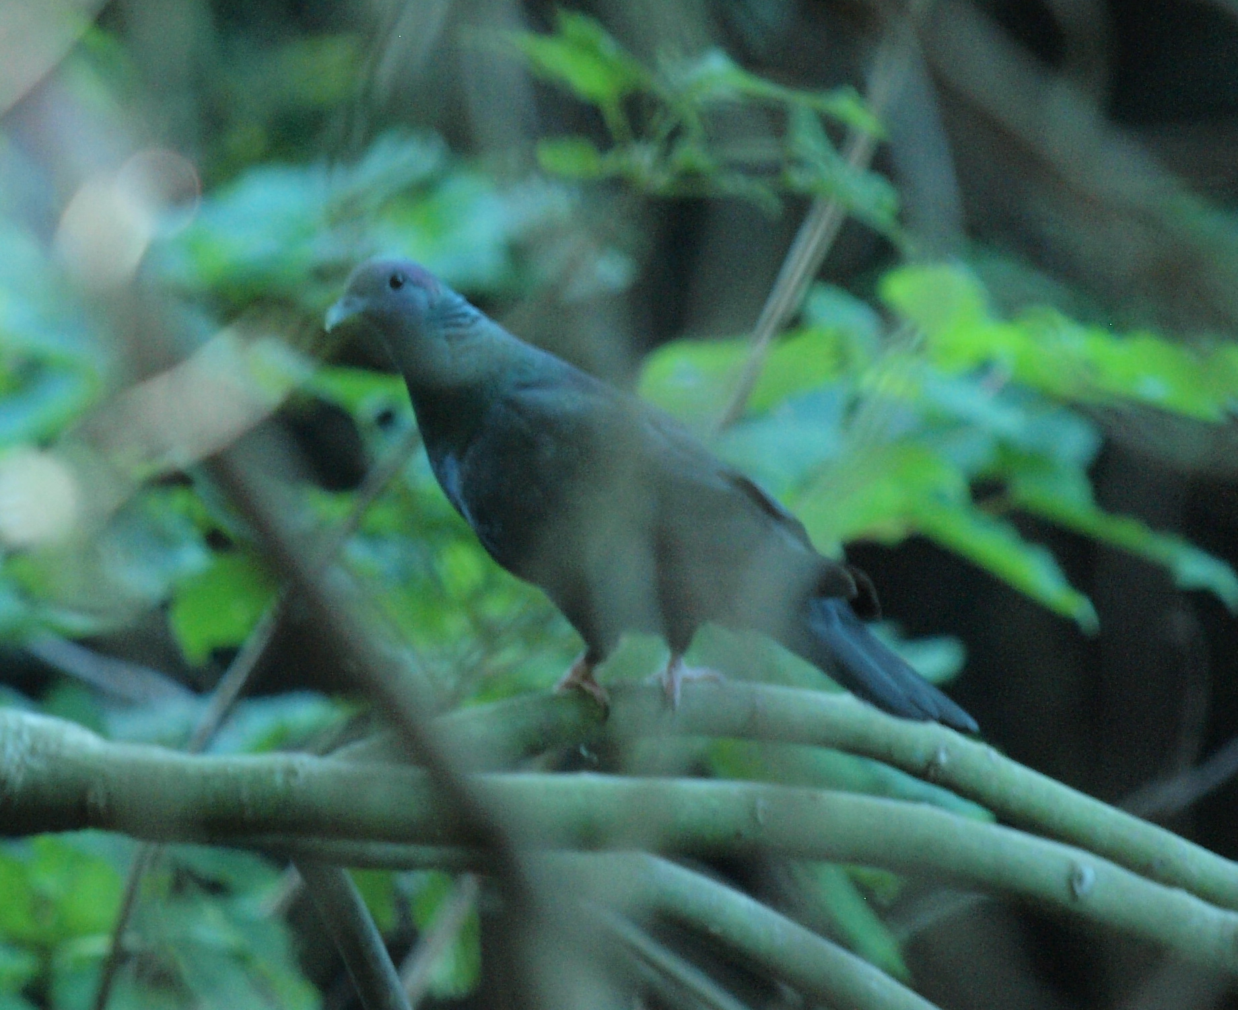 | 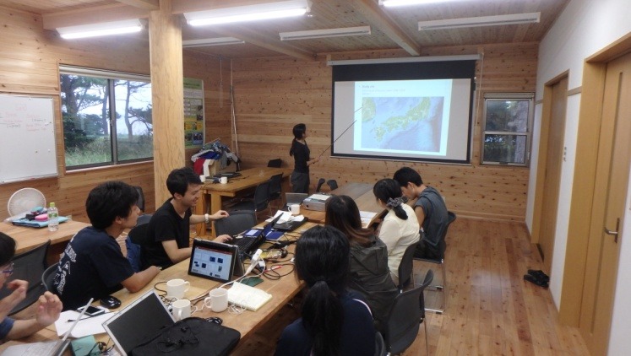
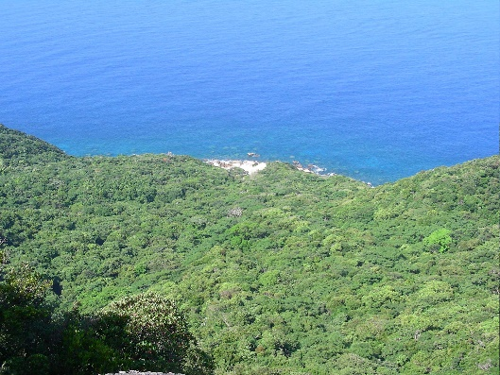 | 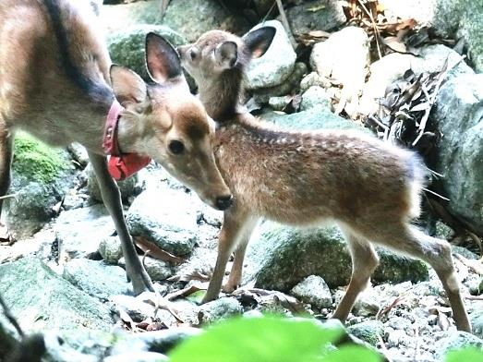 |  | 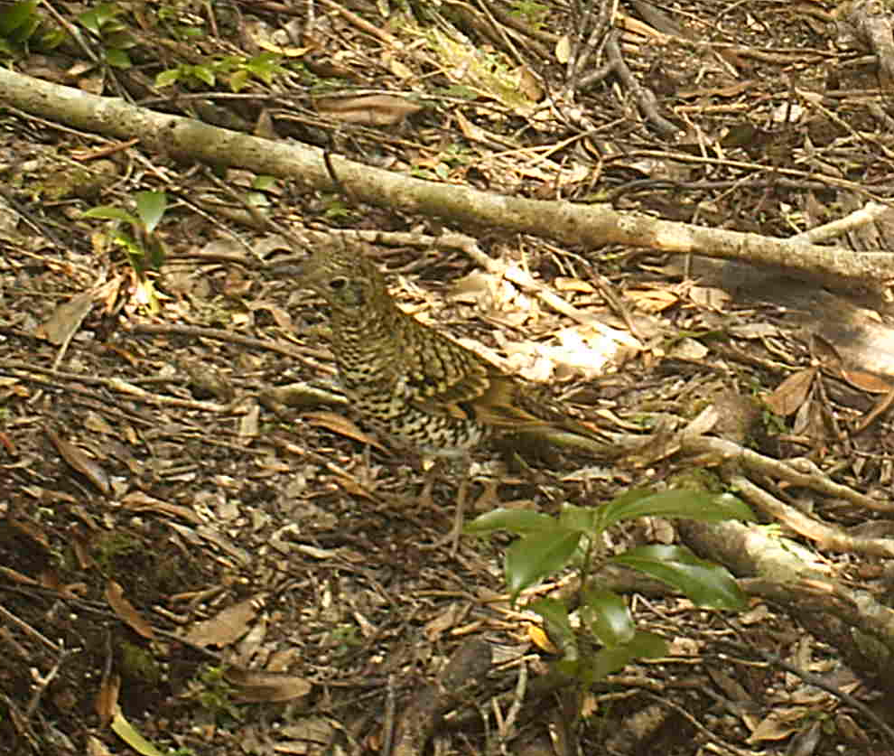

1.2 Application
Graduate students in the Division of Biological Science, Graduate School of Science, Kyoto University (as of Janunary 1, 2022) can apply for the courses. We accept a limited number of participants (c.a. 6 students) due to the safety considerations of fieldwork and COVID-19 and limited capacity for accommodation and transportation.
Applicants must send the form before the deadline. If we have more applicants than our capacity, we will select participants within a week of the application deadline.
Enter at the following site:
https://forms.gle/DxfifzG7wQvCfFwR8

1.3 Credits
Participants can earn credits by taking the courses. We recommend to resister the following courses at KULASIS.
Advanced training in field biology B （野外生物学実習B）

1.4 Fee
Students need to pay 20,000 – 50,000 yen for accommodation, meals, and insurance for the course on the first day. This amount will be paid back to you from the university approximately one month later.
Students must pay the costs of meals other than those provided at our field station (e.g., during travel, lunch on the first day, lunch and dinner on the last day on the way back from Yakushima), and for optional activities such as entrance fees at sightseeing spots (\300-500 / site).

2. Schedule

Advanced training in field biology
January 10 Deadline for application
January 12 Fix the members

Feb 7 Introduction of the course, lectures on safety during fieldwork in Yakushima
Onsite: Seminar room on B1 floor of Wildlife Research Center
Online: Zoom
Feb 14 - 20 Field training
Place: Yakushima Island, Kagoshima Prefecture
Feb 14 Advanced training in field biology starts (Move to Yakushima on this date)
Meeting in the evening: introduction of the lecturers and courses, etc.
Feb 15 - 18 Fieldwork in Yakushima
Feb 19 Fieldwork or data analysis / presentation
Feb 20 Leave Yakushima (if we have time, we will visit some places in Yakushima)
(Flight schedule is not fixed)

Participants must present the results of the courses at the PWS symposium in May 2022.

3. Contents of Advanced training in field biology

3.1 Participants and staff
About 6 graduate students
About 3 teaching staff, including professors, post-docs and graduate students who study in Yakushima and/or subject species.

3.2 Groups
We make one group this time.

Census of mammals and birds in different elevations
Lecturers
Hideki Sugiura (Wildlife Research Center, Kyoto Univ.)
Moto Annegret Naito (Wildlife Research Center, Kyoto Univ.)
Takafumi Suzumura (Wildlife Research Center, Kyoto Univ.)
(We may invite some more lectures)

Abstract
Yakushima Island is mountainous with its peak of 1,936m. We can go up to 1000 - 1200 m above sea level by car along the paved road. We will count mammals (mainly monkeys and deer) and birds walking on the road and try to estimate the abundance of the animals in different elevational zones.

4.0 Reports on the past program and reports
Leading Graduate Program of Primatology and Wildlife Sciences (in English)
http://www.wildlife-science.org/en/curriculum/yakushima-field-science-course.html

5. Information on fieldwork and life in Yakushima Island

5.1. Fieldwork
Research in Yakushima
We will mainly walk on the paved road this time. The highest elevation will be 1200 m ASL and it will be cold, rainy or snowy. Please prepare rain wear, warm clothes and water-proof shoes. We also use binocular to identify the species of birds and age-sex classes of deer and monkeys. If you are not familiar to using binoculars, please practice on them beforehand. We will walk for more than 15 km everyday.

Weather
Check the temperature and precipitation of Yakushima by yourself. We will go at an altitude of 1200 m. At the height, the temperature goes down 7 ℃ from the coastal area.

Wear in the field
･Long-sleeved shirt, long trousers, hat or cap
In general, it is better to wear a long-sleeved shirt and long trousers to cover your skin in the field. They will protect you from insect bites, scratches and strong sunlight. Long trousers should be soft and loose enough to walk on steep slopes. Avoid tight jeans, because they restrict movement and become heavy and hard when wet.

･Footwear
Mountaineering/hiking shoes/boots are best, if you have them. High boots are also good, if you are experienced in walking in the mountains with them. They should be water-proof.
You can rent appropriate footwear from the mountaineering shop in Yakushima and can be reimbursed for such expenses by the university.
If you have old mountaineering shoes, check their soles. Old bonds may become weak, and the soles can fall apart. Almost every year, one or two participants have their soles fall apart.

･Rainwear
Waterproof and breathable fabrics (e.g. Gore-Tex) are highly recommended. You can borrow these as well from the mountaineering shop in Yakushima and be reimbursed for such expenses.

･Gloves
Have gloves against cold. You may have thin gloves that are good for manipulation, such as taking notes and warm gloves together.

5.2. Accommodation and meals
Not fixed yet
Meals
If you have food allergies or food(s) to avoid (e.g., for vegetarians), please let us know.

5.2. List of personal equipment
Equipment for field research (common to all groups)
In addition to below, some other equipment will be necessary depending on your activity. Special equipment in each group will be announced later.

□ backpack (it should be large enough to pack your rainwear and warm clothes, probably around 30 litters)
□ notebook (pocket size is good)
□ pen / pencil
□ marker (with which you can write on plastic sample bags and plastic tubes)
□ canteen (you may use a PET bottle)
□ lunch box and spoon, fork, chopstick (bring a plastic container to pack your lunch to Yakushima)
□ flashlight (and batteries)
□ sampling bag, tube, etc. (they are given to participants at Yakushima)
□ maps (print them before you leave)
□ whistle (you can borrow it from WRC)
□ poison remover (you can borrow it from WRC)
□ compass (you can borrow it from WRC)
□ GPS (you can borrow it from WRC)

□ backpack cover, or plastic bag inside the backpack (optional, when it is rainy)

□ long trousers (and a belt, must)
□ socks (must)
□ hat / cap (we recommend warm cap)
□ gloves (must)
□ rainwear / umbrella (when it is rainy)

□ insect repellent (optional)
□ antipruritic (optional)
□ sunscreen (optional)
□ snack, candy, etc. (optional)
□ adhesive tape (optional, each lecturer has a first-aid kit)
□ towel (optional)
□ tissue (optional)

□ vest (optional)
□ waist pouch (optional)

□ camera (optional)

Other things for stay at the field station
□ underwear
□ clothes (which you can wear in the house)
□ sandals (optional)
□ towel
□ toilet kit
□ laptop (optional; a personal laptop computer is useful for data analysis and presentation of the results)

6. Contact

E-mail: field2022@mail2.adm.kyoto-u.ac.jp
Application: https://forms.gle/DxfifzG7wQvCfFwR8

